# Lab TDD 4: Testing an Exception

## Objectives

In this lab you will add run a test case

The lab continues from where TDD 3 lab leftoff

## Instructions Project Setup

### Step 1: Add a divide test method

1. You are going to add a test method to implement the divide case of 4/2. In this case 2 – 2 == 0
2. 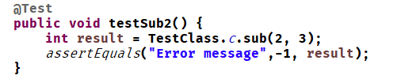Add a test method testDiv1 as shown below
3. Run the tests and ensure the test fails

### Step 3: Add the production code

1. Add the code shown
2. Text

   Description automatically generated with low confidenceRerun the tests and see them pass

### Step 4: Add a second test case for an exception

1. We want to throw an IllegalArgumentException if the user tries to divide by zero
2. Add the zero divide test case 4/0 but notice that there is nothing to test. Add a new test method testDiv2() to do this

1. Graphical user interface, application

   Description automatically generatedThe method throws an exception, in this case an arithmetic exception. When we run the test case, JUnit calls the test an error since an exception was thrown that was not expected.
2. What we can do is to tell JUnit we expect to throw an IllegalArgumentException.

### Step 5: Add the production code

1. Text

   Description automatically generatedAdd the code that throws the correct exception to the implementation
2. Run all the tests and ensure that they all pass